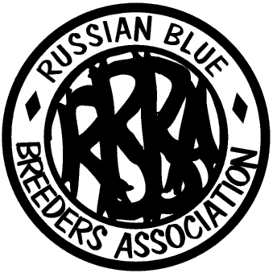
Russian Blue Breeders’
Association

Show Sponsorship

Please use this form to sponsor Classes of your choice which is a wonderful way to support our Show. Your name (and/or Prefix) will be printed in the Catalogue under the Class(es) you sponsor.

CATEGORY | Price | Class Number | Total per Category
Best in Show | £5
Best in Show Adult | £5
Best in Show Kitten | £5
Best in Show Neuter | £5
Best in Show Non-Pedigree | £5
Breed Classes | £4
Miscellaneous Classes | £3
Decorated Pens | £4
Donation
Total Sponsorship Offered |  |  | £

I agree that you may re-allocate my sponsorship to a different class if category is already sponsored or classes cancelled.

Name of Sponsor ………………………………………………………………….

Address…………………………………………………………………………………

…………………………………………………………………………………………

E-mail:………………………………………….

Telephone…………………………..…………..

