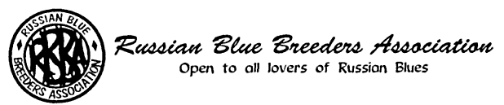
NOMINATION FORM

NAME OF NOMINEE: .........................................................................................................................

POSITION FOR WHICH NOMINATED: ..............................................................................................

NOMINATED BY:

1. NAME ...................................................... SIGNATURE .....................................................

2. NAME ………………………..................... SIGNATURE .....................................................

PERSONAL DETAILS OF NOMINEE

a) Date joined the RBBA (if known) .............................................................................................

b) Office, Committee membership or other Association posts now or in the past and period held

................................................................................................................................................

- Offices, or Committee memberships presently held in other cat clubs: ................................

...............................................................................................................................................

d) Other relevant qualifying factors, e.g. Russian Blue Judge, past Secretaryships in other organisations, experience in Show Management etc:

I confirm that the above details are correct, that I am not on the Committee of more than two other cat clubs and I accept nomination for the position above.

SIGNATURE OF NOMINEE ................................................................. DATE ...........................

Please return the completed form to the Hon. Secretary:

Miss A Cooper, 17 Blenheim Road, Solihull B90 3QE
Email: angie.cooper@blueyonder.co.uk

